COURSE: CLOUD AND NETWORK SECURITY _C1-2024

STUDENT NAME: LENNIE NTHIGA
STUDENT NO: cs-cns07-24170
SEPTEMBER 18,2024

WEEK 2 ASSIGNMENT 1
CLASS EXERCISE: PACKET TRACER - BUILD A SWITCH AND ROUTER NETWORK

INTRODUCTION
The below exercise is a design of a simple network topology involving a router switch and two pcs pc A and B. This illustration shows ways of configuration of pcs ipv4 and ipv6 and gateways the configurations of a routers used ports and making sure there’s a communication between both pcs.

SETUP:
We would require two pcs A and B, switch, router, console cable and ethernet cable
The console cable is a cable connected from PC-A to a router and PC-B to switch for purpose to access the switch or router cli panel for configurations or diagnosis
While the ethernet cable would be connected from PC-A to the switch and from the switch to the router and from the router to the PC-B
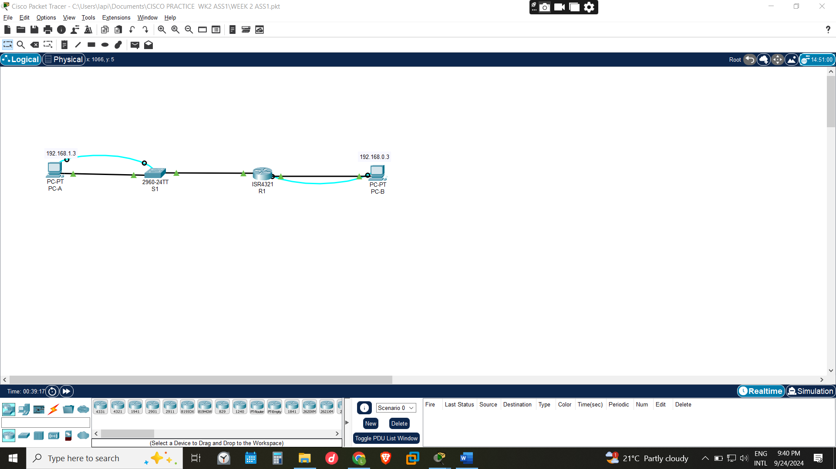

Configuring PC-A and PC-B
PC-A and PC-B can be given ipv4 addresses automatically by enabling DHCP however we would be allocating prefeed ipv4 and ipv6 addresses the gateway being the Ip of the port the pc is connected to the network device. in this case PC-A was connected to Ip 192.168.1.1 being the port the swich was connected to the router
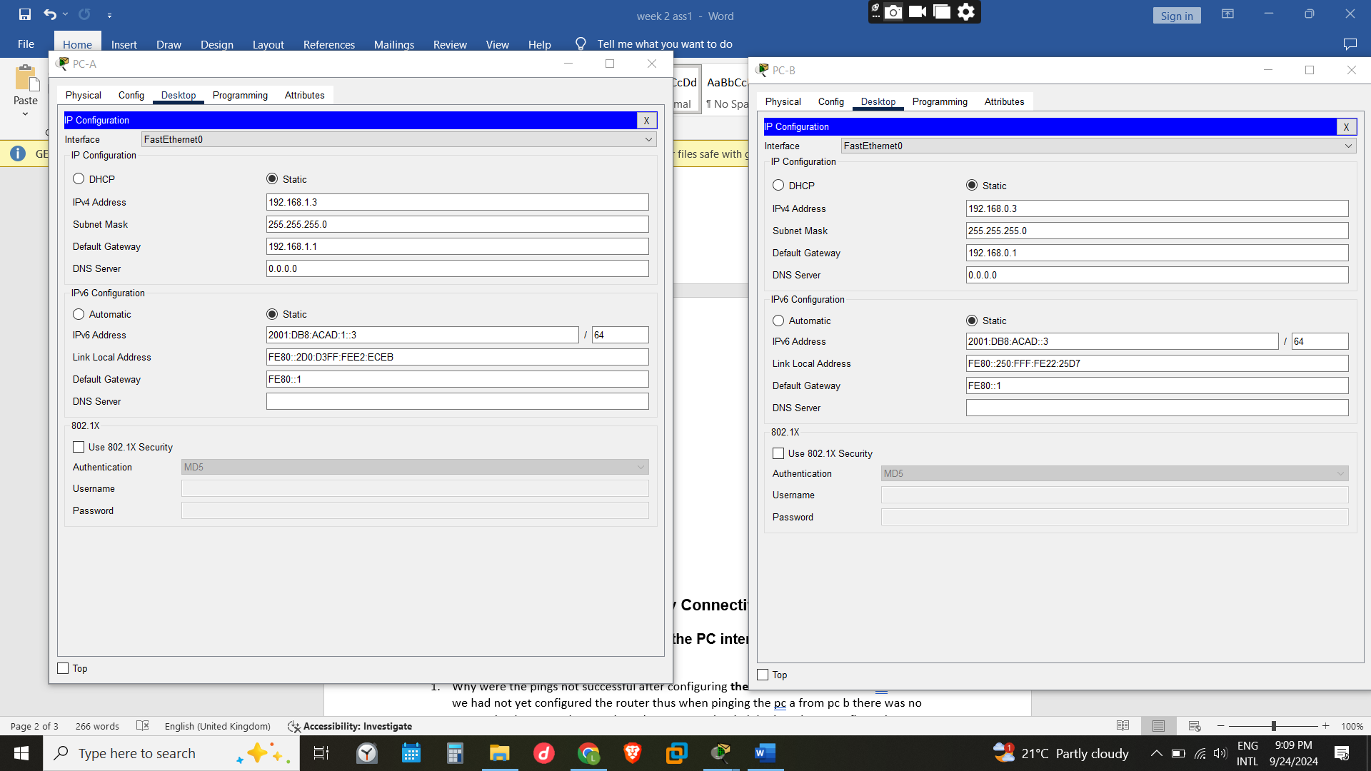

Part 2: Configure Devices and Verify Connectivity
The console cable connected from PC-A to switch and PC-B to router was to be used to connect the network devices in pcs terminal to access the cli for configurations
This has now enabled one to have created a remote access to the network devices for configuration. In this case would have configured the switch and the router from PC-B. However, the configurations would have been implemented on both router and switch without necessarily using pc a.
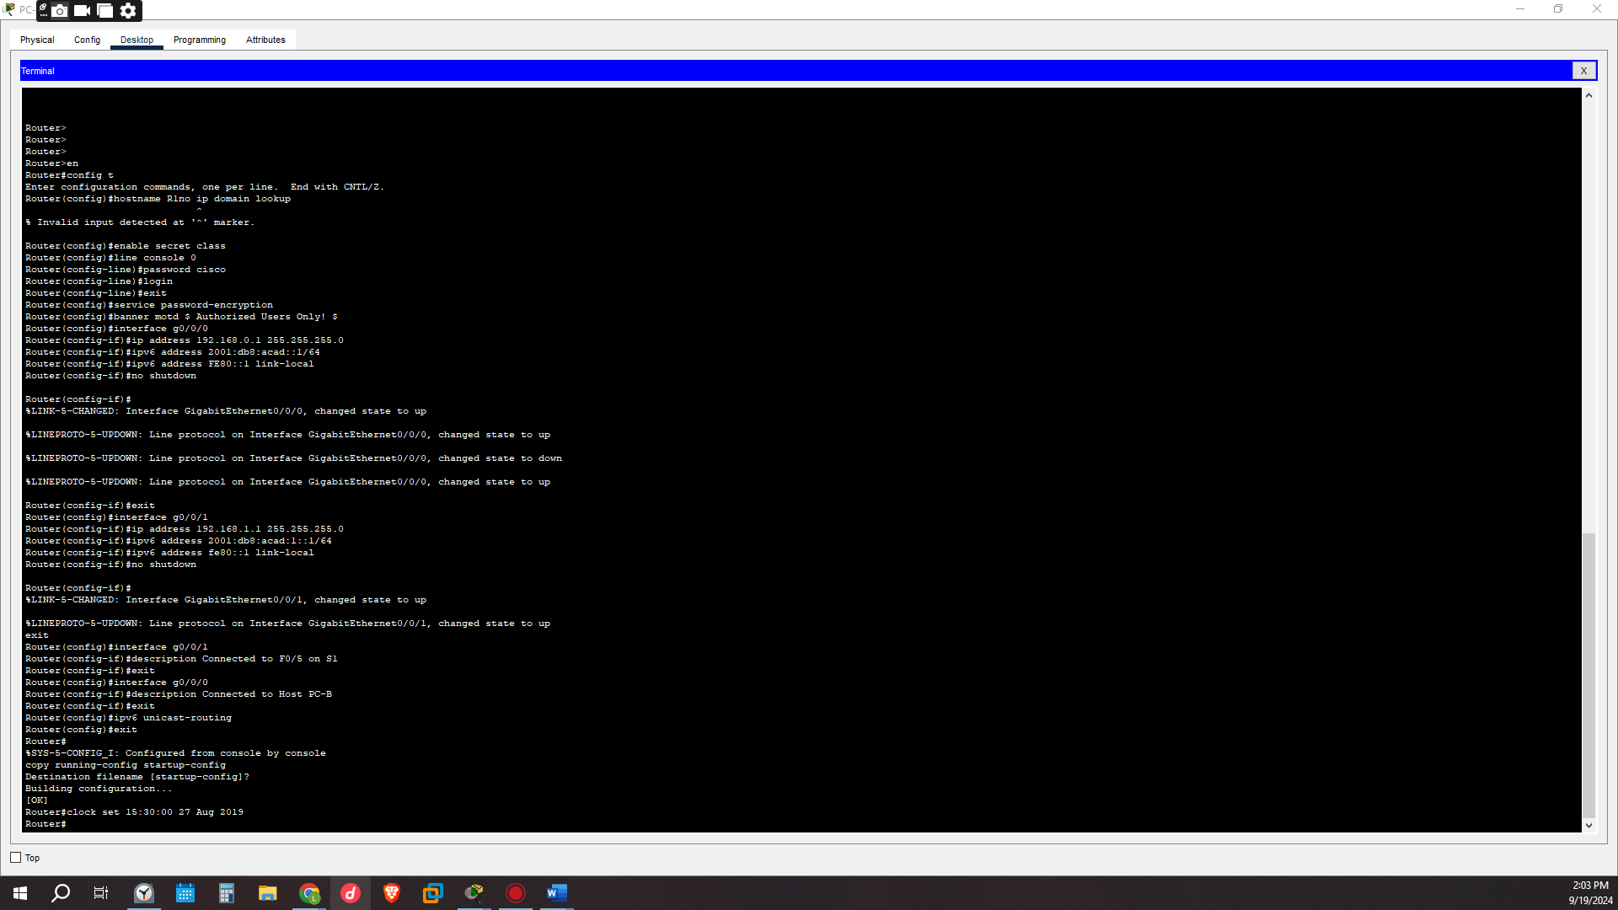
We would configure the following:
- The router and switch name
- Enabling privileged EXEC mode in passwords for encrypted password
- The console password and enabling login
- Configuring and activating the router interface that are to be active as connected, the ipv4 and ipv6 address that were assigned
- The descriptions of each of the interfaces indicating the devices connected
- Activating the VLAN interface on the switch S1.
the configuration of the routers and switches and the pcs would be the last point of connecting the network to make sure there’s is communication happening one would ping PC-A to PC-B and see if there would be a response which indicates the successfully connection of the network

we can see below from the routers network interface brief that the ports are up
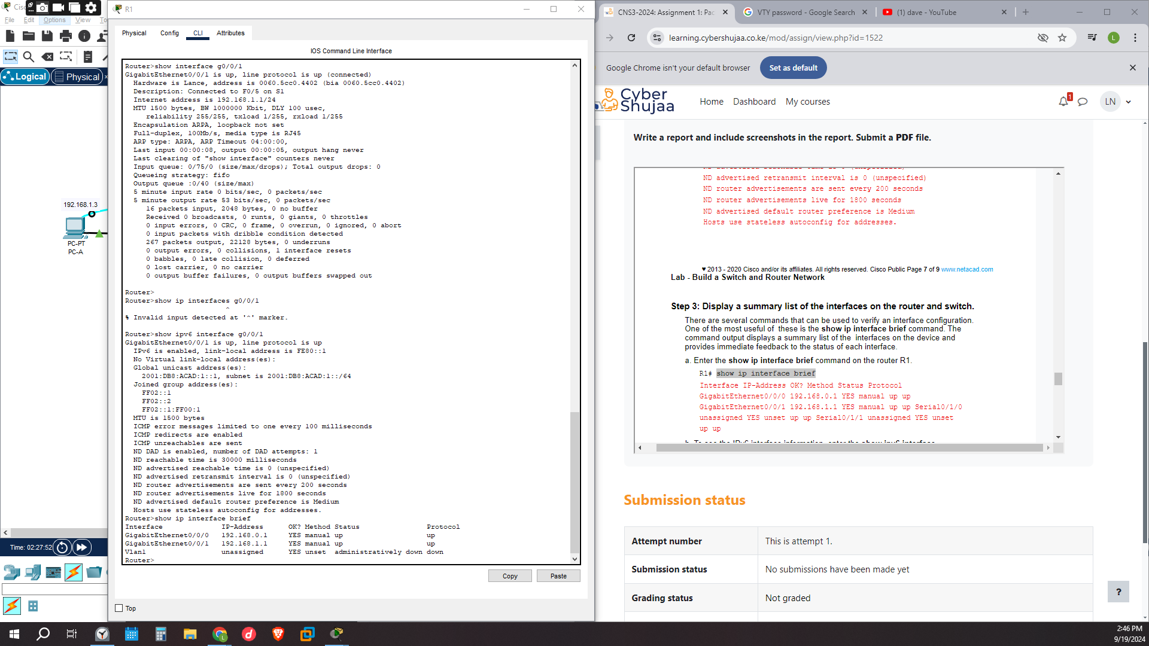
The switch interface brief information the fast ethernet ports 1 and 2 are shown to be up and running
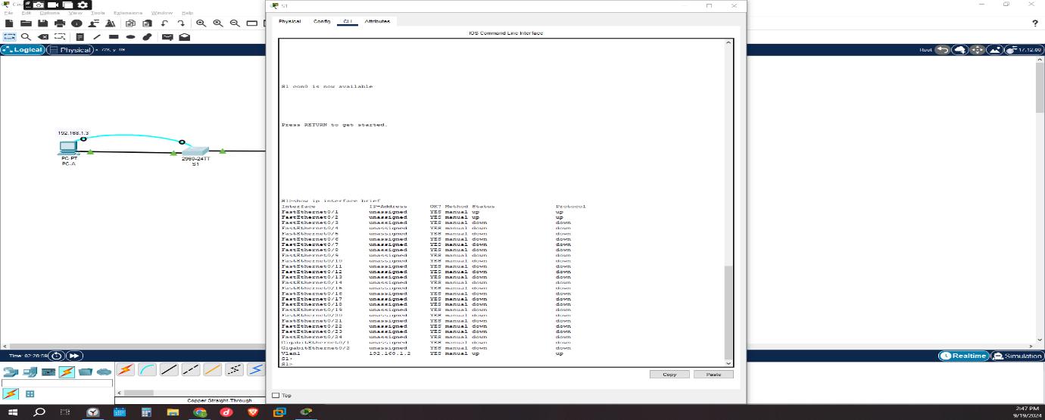
Pinging pc b from the switch cli we can see the communication is successful even from pinging from pc a to pc b the communication would also be successful.
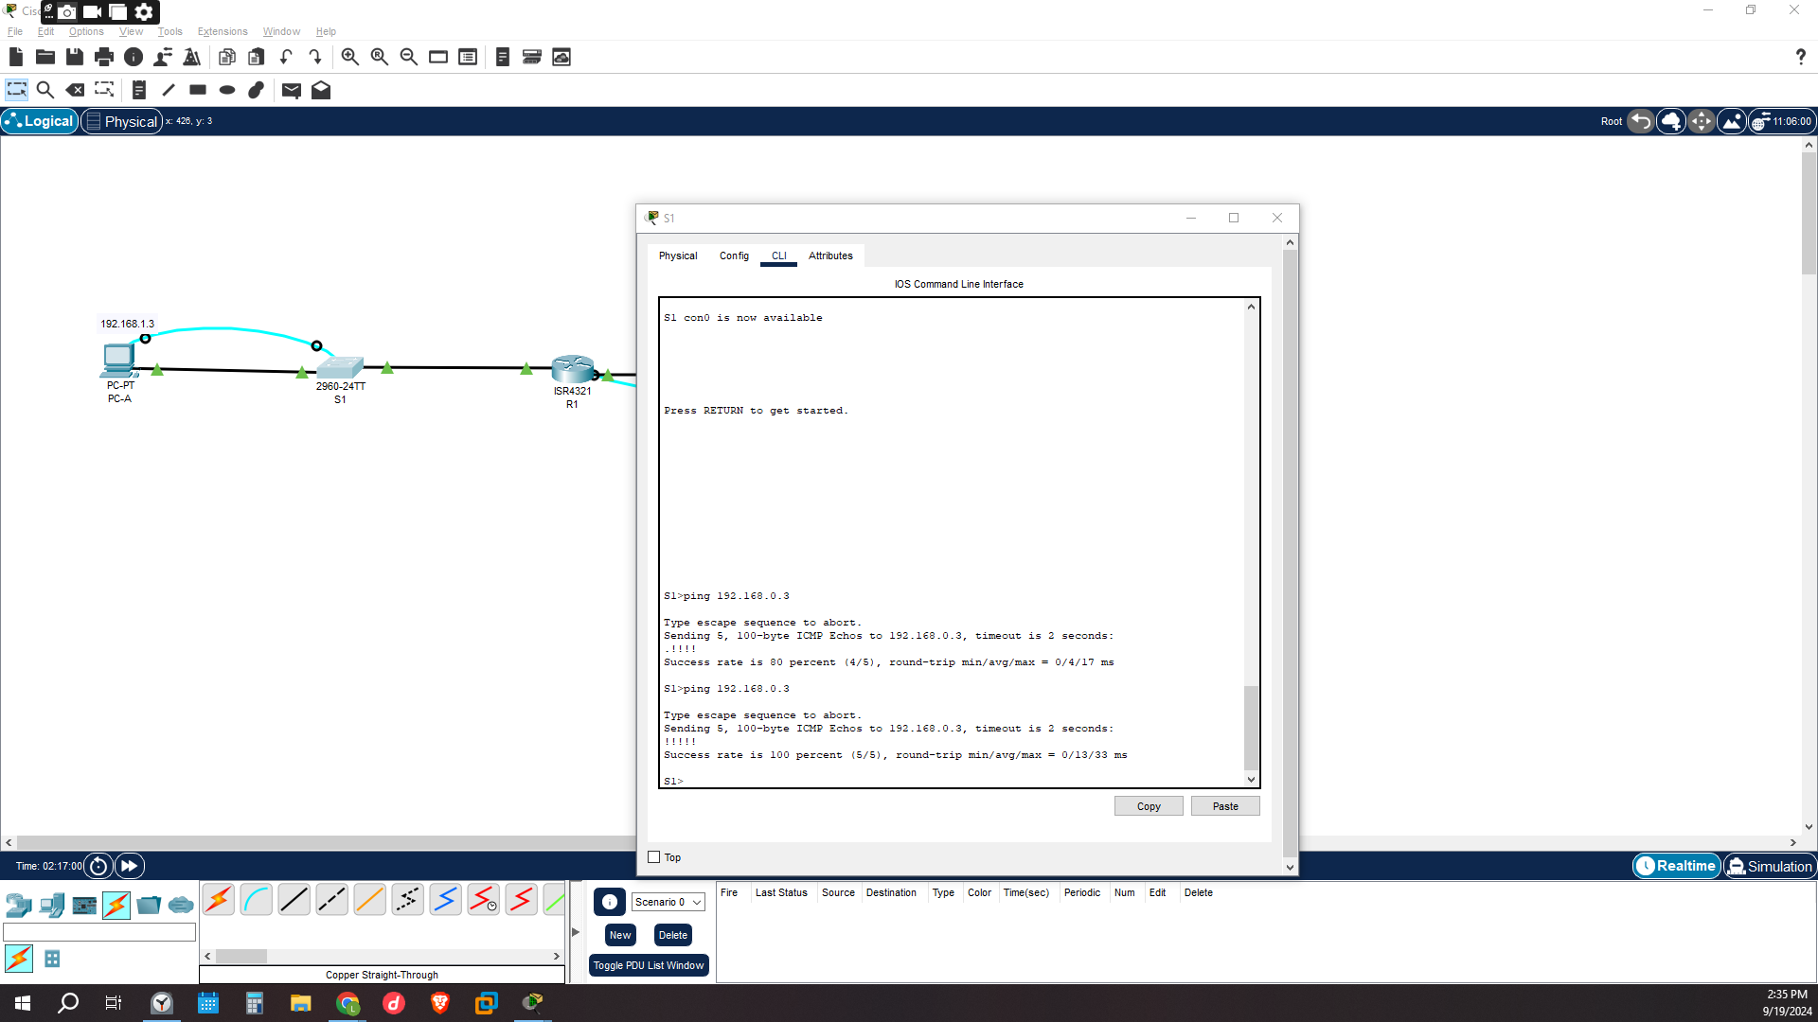
Question:
Step 1: Assign static IP information to the PC interfaces.
- Why were the pings not successful after configuring the PC-A AND PC-B ONLY? it’s because we had not yet configured the router thus when pinging the pc, a from pc b there was no connection between the two since the router and switch had not been configured to Pc a and pc b
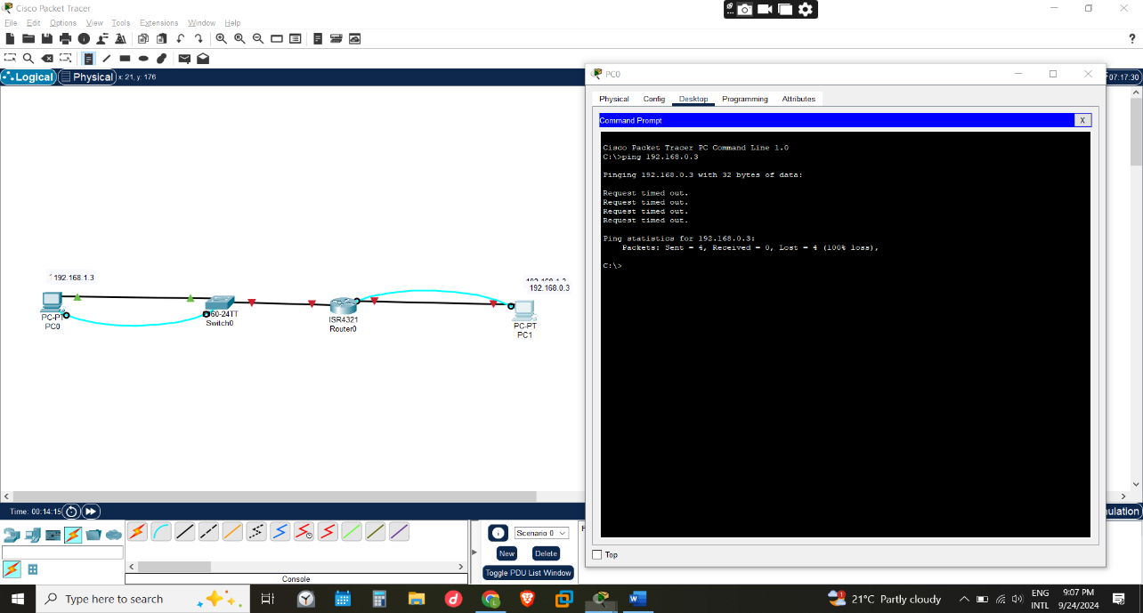

Step 2: Configure the router.
- After router and switch configurations Ping PC-B from a command prompt window on PC-A.
Were the pings successful? Explain. YES. This is because the router was configured with information about the routers interfaces together with the pcs assigned ipv4 and ipv6 addresses
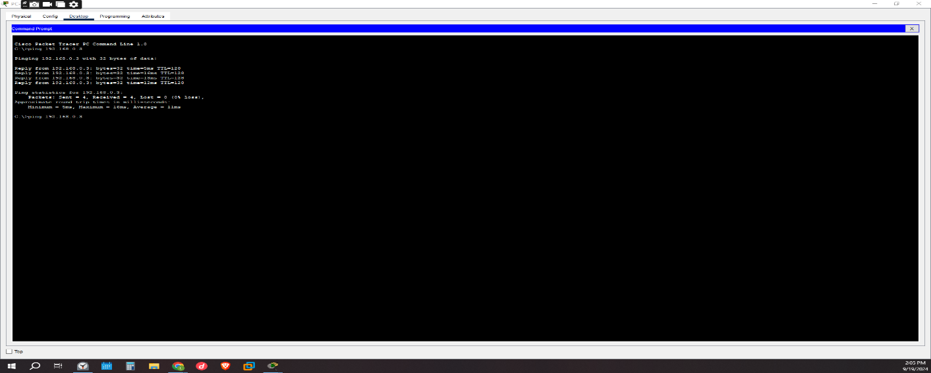

PART 3:
Step 1: Display the routing table on the router
- What code is used in the routing table to indicate a directly connected network? C (Codes: L - local, C - connected, S - static, R - RIP, M - mobile, B - BGP)
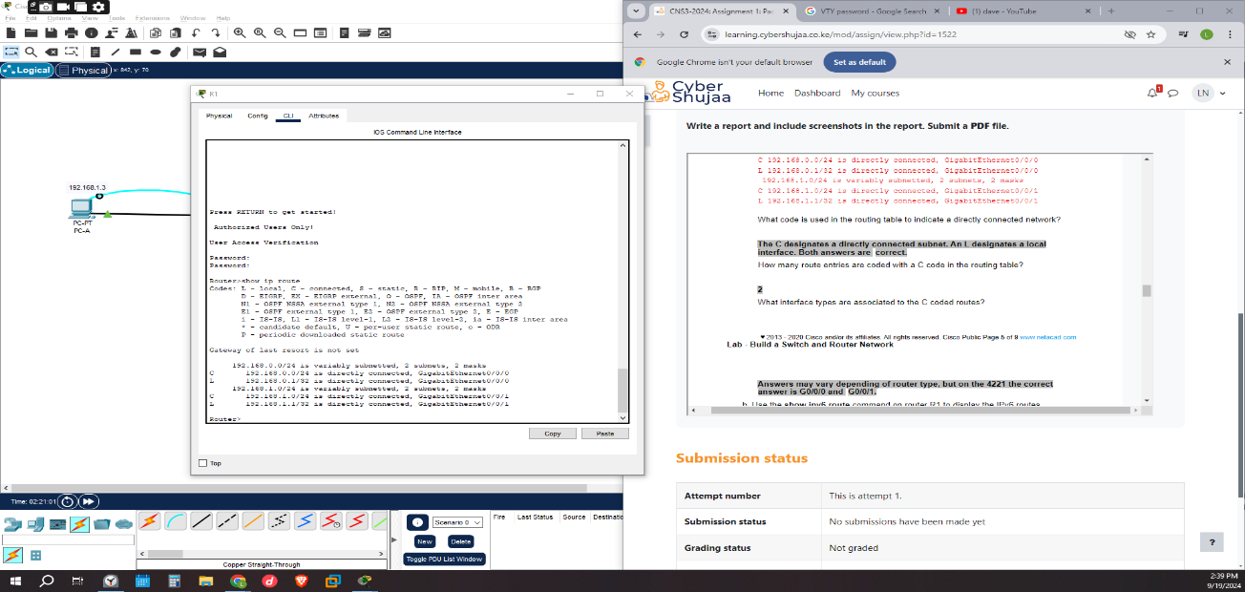

- What interface types are associated to the C coded routes? GigabitEthernet0/0/0
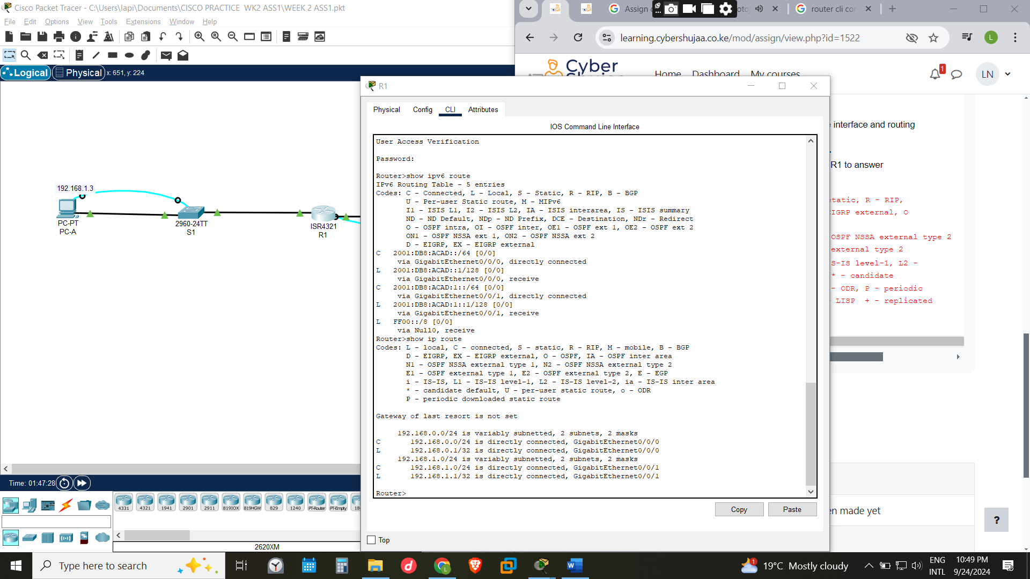

Step 2: Display interface information on the router R1.
- What is the operational status of the G0/0/1 interface? GigabitEthernet0/0/1 is up, line protocol is up (connected)
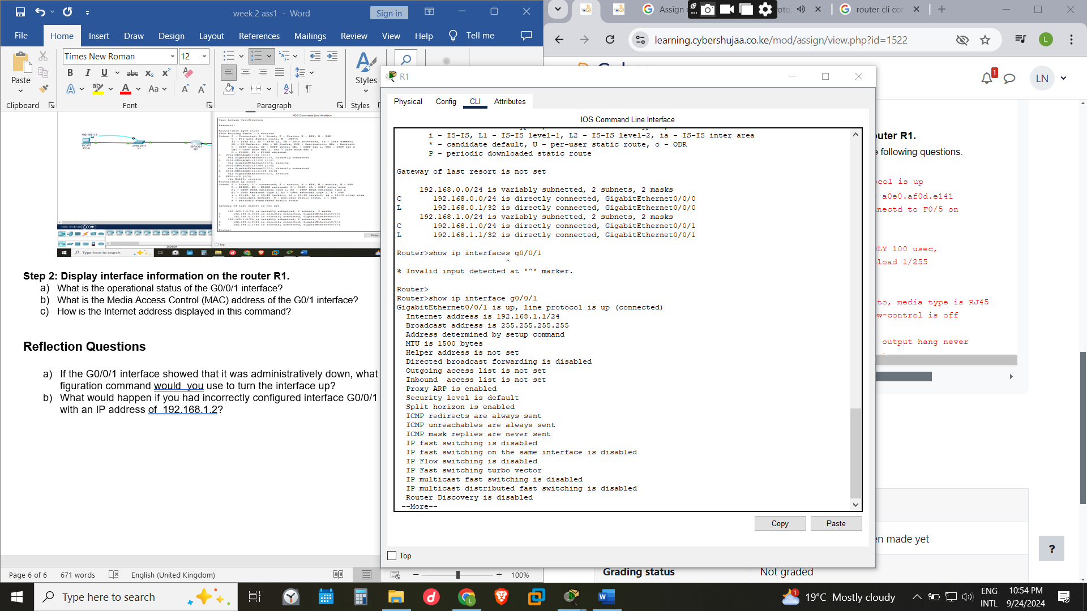
- What is the Media Access Control (MAC) address of the G0/1 interface?
- How is the Internet address displayed in this command? Internet address is 192.168.1.1/24

Reflection Questions
- If the G0/0/1 interface showed that it was administratively down, what interface configuration command would you use to turn the interface up? no shutdown in the cli
- What would happen if you had incorrectly configured interface G0/0/1 on the router with an IP address of 192.168.1.2? the router would recognize 192.168.1.2 as part of another network which does not exist thus when pinging pc, a to pc b the it wouldn’t be successful

CONCLUSION
From the activity we find out that the pc routers interfaces connected with the Ethernet cable to the pcs have to be given an Ip which would be the gateway of the pc connected to since that’s the entry and exit point of the communication. I have noticed that the switch shares the same gateway as PC-B since they have the same entry point at the router. Misconfiguration of the Ip-address and the interfaces in cli can bring a false connection making communication of the devices difficult

